Car model

Development and verification

Development: Davide Capuzzo

Verification: Federico Galli

Last revision on {UPDATE DATE, format dd/mm/yyyy}

# Introduction

Verification of subsystem is very important in a model base design have a global model of the car necessary for tested all the sub-system model of the many element of the car. In order to have a full test also an ideal environment is necessary.

Simulink provide an idea of how to organize the simulation environment sending also the parameters of some maneuvers that stress a lot the component of the car, the goal of that maneuvers are to find some boundary condition and test in a virtual environment how a new model of a component collaborate with the other component to react on the external condition. Another useful things that is provide by Simulink is the simulation of the driver behavior this is needed to perform a better simulation of the car

## System requirements

In order to interface with the model, the following software modules are required:

* MATLAB R2019b and Simulink

The additional libraries required are:

# Requirements

The goal of this model is to create an environment with a model of an entire vehicle and a simulation of the driver in order to evaluate the virtual differential.

This vehicle is a electric sedan with a central battery pack. The are also four in-wheel motors that provide the necessary torque to drive the car. The virtual differential have to provide the right torque to each wheel in order to perform as a mechanical active differential.

The simulation of the environment where the car is driven and the behavior of the driver are predefined MATLAB block necessary to simulate this complex system.

# Model-based design

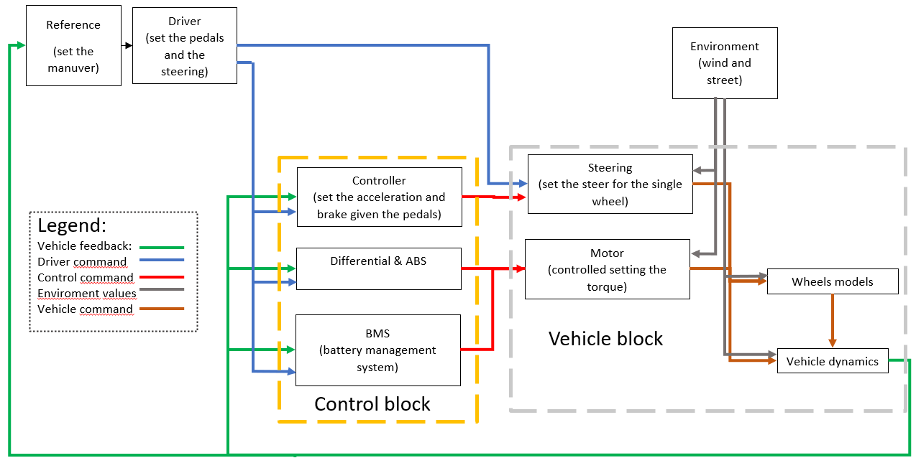The matlab models are organized in such way

* The refence generator block is a MATLAB block that generate the reference for a simulation to evaluate a car model, in this block it is possible to set the kind of the maneuver and the condition for this maneuver
* The driver command is a MATLAB block that given as input the feedback of vehicle dynamics and the reference of the maneuver give in output the ratio of the throttle and brake pedals and the steering angle, simulating the driver behavior in a predictive way.
* In the control block there is all the electronic control of the vehicle in particular giving as input the command of the driver and the vehicle feedback manage the battery, control the motors and brake. In this block there is the torque repartion to control the ABS, ESP and virtual differential.
* In the environmental block there is all the parameters to simulate the interaction between the car and the environment.
* In the passenger vehicle block there is all the model of a standard electric sedan car. Inside it is split in two modules:
  + The mechanic block where inside there is the model of the steering, the models of the brake, the models of the motors and the batteries
  + The body block where inside there is the model of the chassis, the model of the road

# Usage

## System parameters

In this model it is possible to set many parameters of the car and many parameters of the various kind of maneuver to evaluate a complete simulation of any electric vehicle with four in wheel motors.

In the appendix there is all the list of the parameters that it is possible to set.

# Verification

{TODO: describe verification process (i.e. does it satisfy requirements and interfaces?)}

## Appendix

Vehicle parameters  
Forward location of tire, a [m]:

VEH.FrontAxlePositionfromCG = 1.515000000000000

Rearward location of tire, b [m]:

VEH.RearAxlePositionfromCG = 1.504000000000000

Vehicle mass, m [kg]:

VEH.Mass = 1181

Track hardpoint coordinates relative to axle center, Track Coords [m]

VEH.TrackWidth = 1.9220

Vertical distance from center of mass to axle plane, h [m]

VEH.HeightCG = 0.1340

Initial position in inertial frame [Xeo,Yeo,Zeo], Xe_o [m]:

VEH.InitialLongPosition = 0

VEH.InitialLatPosition = 3.1250

VEH.InitialVertPosition = 0

Initial velocity in body axes [xdot_o,ydot_o,zdot_o], xbdot_o [m/s]:

VEH.InitialLongVel = 0

VEH.InitialLatVel = 0

VEH.InitialVertVel = 0

Initial Euler orientation [roll, pitch, yaw], eul_o [rad]:

VEH.InitialRollAngle = 0

VEH.InitialPitchAngle = 0

VEH.InitialYawAngle = 0

Initial body rotation rates [p,q,r], p_o [rad/s]

VEH.InitialRollRate = 0

VEH.InitialPitchRate = 0

VEH.InitialYawRate = 0

Chassis inertia tensor, Iveh [kg*m^2]

VEH.RollMomentInertia = 1.9227e+03

VEH.PitchMomentInertia = 432.3333

VEH.YawMomentInertia = 2066

Longitudinal drag area, Af [m^2]:

VEH.FrontalArea = 2.1100

Wheel radius, [m]

VEH.WheelRadius = 0.31;

max speed [m/s]

VEH.MaxSpeed = 160/3.6;

Suspension

block: solid axis suspension (Coil spring)

Axle and wheels lumped principal moment of inertia about longitudinal axis, AxlIxx [kg*m^2]

AxlIxx = 62.37451666666666

Axle and wheels lumped mass, AxlM [kg]:

AxlM = 160

Wheel and axle interface compliance constant, KzWhlAxl [N/m]

KzWhlAxl = 138031.6120778669

Wheel and axle interface compliance preload, F0zWhlAxl [N]

F0zWhlAxl = 2907

Wheel and axle interface damping constant, CzWhlAxl [Ns/m]

CzWhlAxl = 11490.97125702646

Suspension spring constant, Kz [N/m]

Kz = 52451.00657928319

Suspension spring preload, F0z [N]:

F0z = [2886 2907]

Suspension shock damping constant, Cz [Ns/m]

Cz = 5565.224643801984

Suspension maximum height, Hmax [m]

Hmax =0.25

Vehicle Adapter

h = 0.134

vehicle mechanics parameters

Litium ion battery pack

Rated capacity at nominal temperature, BattChargeMax [Ah]:

BattChargeMax = 32.5

Open circuit voltage table data, Em [V]:

Em = [2.8 3.228 3.284 3.361 3.408 3.427 3.472 3.477 3.493 3.504 3.516 3.528 3.537 3.545 3.555 3.561 3.566 3.576 3.587 3.589 3.594 3.6 3.608 3.61 3.616 3.619 3.626 3.632 3.637 3.64 3.645 3.646 3.652 3.655 3.658 3.661 3.664 3.668 3.673 3.678 3.68 3.681 3.686 3.692 3.699 3.702 3.705 3.71 3.717 3.723 3.728 3.733 3.735 3.742 3.749 3.755 3.761 3.768 3.773 3.78 3.791 3.798 3.798 3.814 3.818 3.825 3.841 3.846 3.855 3.863 3.877 3.885 3.894 3.907 3.919 3.926 3.935 3.944 3.954 3.964 3.974 3.988 3.998 4.014 4.029 4.034 4.047 4.065 4.074 4.086 4.097 4.131 4.126 4.138 4.15 4.18 4.174 4.187 4.207 4.231 4.221]

Open circuit voltage breakpoints 1, CapLUTBp []:

CapLUTBp = [0 0.01 0.02 0.03 0.04 0.05 0.06 0.07 0.08 0.09 0.1 0.11 0.12 0.13 0.14 0.15 0.16 0.17 0.18 0.19 0.2 0.21 0.22 0.23 0.24 0.25 0.26 0.27 0.28 0.29 0.3 0.31 0.32 0.33 0.34 0.35 0.36 0.37 0.38 0.39 0.4 0.41 0.42 0.43 0.44 0.45 0.46 0.47 0.48 0.49 0.5 0.51 0.52 0.53 0.54 0.55 0.56 0.57 0.58 0.59 0.6 0.61 0.62 0.63 0.64 0.65 0.66 0.67 0.68 0.69 0.7 0.71 0.72 0.73 0.74 0.75 0.76 0.77 0.78 0.79 0.8 0.81 0.82 0.83 0.84 0.85 0.86 0.87 0.88 0.89 0.9 0.91 0.92 0.93 0.94 0.95 0.96 0.97 0.98 0.99 1]

Internal resistance table data, RInt [Ohms]:

RInt = [0.008846 0.009319 0.009027 0.00847 0.01032 0.01314;0.006389 0.006554 0.005553 0.005525 0.006043 0.007805;0.004364 0.004101 0.00406 0.003452 0.003846 0.004517;0.002031 0.002563 0.002532 0.00246 0.002716 0.003047;0.001443 0.001825 0.001795 0.001778 0.001924 0.002234;0.0005603 0.0007192 0.0006887 0.0007557 0.0007355 0.001014;0.001028 0.001338 0.001 0.001536 0.001546 0.002789]

Battery temperature breakpoints 1, BattTempBp [K]:

BattTempBp = [243.1 253.1 263.1 273.1 283.1 298.1 313.1]

Battery capacity breakpoints 2, CapSOCBp []:

CapSOCBp = [0 0.2 0.4 0.6 0.8 1]

Number of cells in series, Ns []

Ns = 96

Number of cells in parallel, Np []:

Np = 2

Initial battery capacity, BattCapInit [Ah]:

BattCapInit =26

motors

Torque control time constant, Tc, [s]:

Tc = 0.02

Maximum torque, torque_max [Nm]:

torque_max = 280

Maximum power, power_max [W]:

power_max = 80000

control block parameter

Battery control

max battery charge

BattChrgMax = -80000

max battery discharge

BattDischrgMax = 80000

charge limiting

ChrgLmt_bpt = [1 1 1 1 1 1 1 1 0.7 0.35 0]

discharge limiting

DischrgLmt_bpt= [0 0.35 0.7 1 1 1 1 1 1 1 1]

SOC_bpt = [0 10 20 30 40 50 60 70 80 90 100]

Brake control

Converts Brake Pedal Position to Brake Pressure Request

BrkPrsMax = 5000000

throttle control

Accelerator Pedal Position to Torque Command

MotSpd = [0 1000 2000 2728.370453 3000 4000 5000 6000 7000 8000 9000 10000]

MotTrq = [280 280 280 280 254.6479089 190.9859317 152.7887454 127.3239545 109.1348181 95.49296586 84.88263632 76.39437268]